Daniel Opdahl

Millikan oil drop experiment

In the Millikan oil drop experiment, I calculated the charge of various oil droplets based on their velocity when falling (only experiencing forces due to gravity and air resistance), their velocity when rising (only experiencing forces due to gravity, air resistance, and electrical attraction), the air resistance calculated from the electrical resistance between the two plates, the density of the oil used, the separation of the two plates, and the acceleration due to gravity.

Setup

The apparatus used for the Millikan oil drop experiment, shown in Figure 1, utilizes a main chamber, a switch to control the opening of the chamber and the exposure of alpha particles to the chamber, a light source, a camera, and a voltage source. The light source we utilized as a simple LED light bulb that shown into the main chamber through a built-in window. This is necessary to provide light for the camera that can see into the main chamber thanks to another built-in window. The camera we used looked into the main chamber area between the plates where the droplets were. The voltage source provides the voltage for the main chamber.

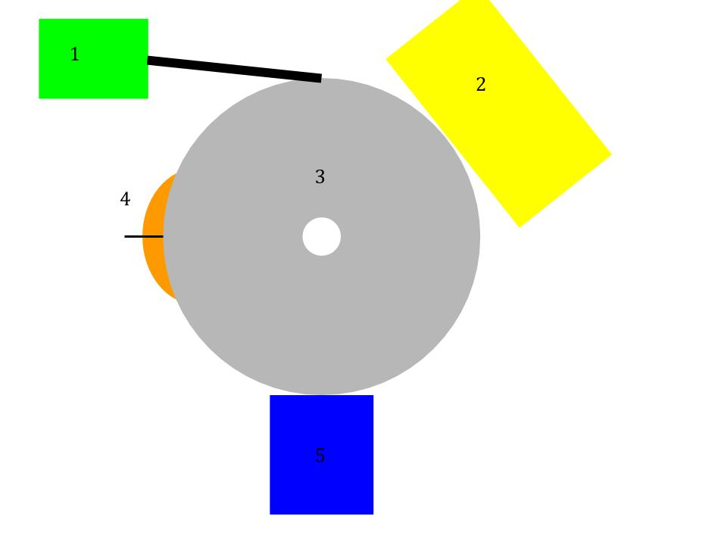

Figure 1: A general schematic for the Millikan oil drop experiment containing (1) a voltage source connected to the main chamber, (2) a light source to illuminate the inside of the main chamber, (3) the main chamber were oil drops are viewed and where the plates are, (4) a switch controlling the opening and closing of the main chamber along with the exposure of alpha particles to the main chamber, (5) a camera that looks into the main chamber.

The main chamber, shown in Figure 2, consists of an opening in the top of the chamber that allows oil droplets to be sprayed in via an atomizer, two plates that have a voltage provided by the voltage source, an alpha source that can be turned off and on that exposes the oil drops to alpha radiation and changes their charges, and two aforementioned windows for the light source and the camera.

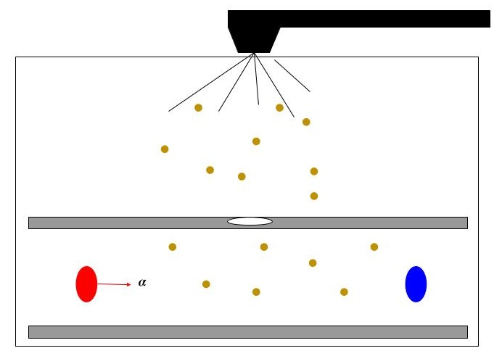

Figure 2: A schematic of the main chamber. Oil drops are sprayed into the chamber by an atomizer and allowed to fall through a small hole in the top plate to enter the area between the plates. The red circle represents the port controlled by the switch that allows the main chamber to be exposed to alpha particles, and the blue circle represents the viewing window for the camera.

On the top and bottom of the chamber are two horizontal parallel plates that have electrical potential , separated by distance .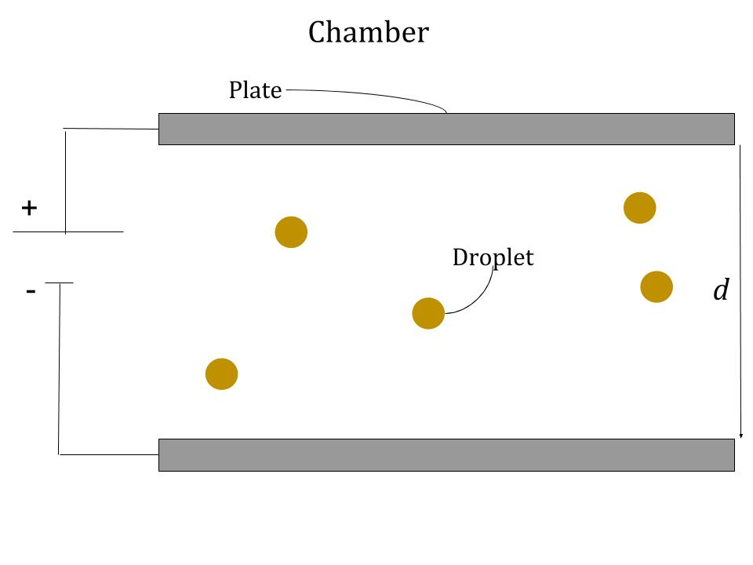

Figure 3: A close up of the area between the two plates with applied voltage between them, separated by distance *d*. When oil droplets are allowed to fall in between the two plates and no electric potential is applied, the drops reach terminal velocity and fall at a constant speed, experiencing the downward force of gravity balanced with the upwards force of air resistance. If an electric potential is applied between the plates, an electric field is created that causes the droplet to rise if the droplet has charge . The droplet will then rise at a constant speed of .

When oil droplets are allowed to fall in between the two plates and no electric potential is applied, the drops reach terminal velocity and fall at a constant speed, experiencing the downward force of gravity balanced with the upwards force of air resistance. This relationship is modeled by Equation 1 as follows

(1)

where is the force of air resistance, and is the force of gravity.

Stoke’s law provides a formula, shown in Equation 2 below, that describes the force of air resistance on a drop

(2)

Where is the radius of the drop, is the viscosity of air, and is the velocity of the drop in free fall.

Combining this with Equation 3, shown below,

(3)

where is mass, and is the acceleration due to gravity, yields Equation 4 as follows.

(4)

Representing the mass of the drop as the volume times the density yields

(5)

where is the density of the oil (). Using Equation 3 and Equation 2, we can determine an expression for the radius of the oil drop

(6)

which allows us to determine the radius of the droplet using its falling velocity.

If an electric potential is applied between the plates, an electric field is created that causes the droplet to rise if the droplet has charge . The droplet will then rise at a constant speed of . This relationship can be modeled by Equation 7 shown below

(7)

Where is the force of gravity and is the force of the air resistance. A visual of the forces acting on the droplet with and without the presence of the electric field is shown in Figure 4 below.

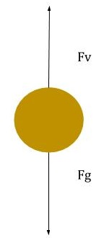 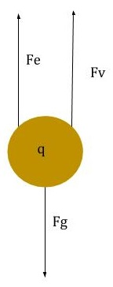

Figure 4: When there is no voltage applied to the plates, a droplet will experience only the forces of gravity and air resistance and , respectively, as shown in the left image. When a voltage is applied, a droplet with charge will experience forces of electrical attraction, gravity, and air resistance, , , and , respectively.

Since , we can derive Equation 8 as follows

(8)

Because the electric field is given by the voltage between the plates, , and the distance separating the plates, , and because can be substituted for its equivalent value in Equation 23423, we can solve for , the charge on the droplet.

(9)

Method

Each time we gathered data, we began by firstly connecting the power supply to the apparatus and setting the voltage to 200 volts. We then measured the thermistor resistance using the multimeter. We then connected the camera to our lab computer and focused the camera such that the grid lines shown in the image were in focus. We also made sure to rotate our camera so that the grid lines were horizontal and vertical and so that the light source was illuminating the majority of the image. Then, we moved the ionization switch to the “SPRAY DROPLET POSITION”, and placed the nozzle of the atomizer on the opening at the top of the chamber. We then used the atomizer to spray some oil droplets into the chamber. After that, we turned the ionization switch to the “OFF” position.

After waiting a moment, the droplets floated down into the area between the plates and appeared on our camera image, after we focused the camera in and out for a while. We then used the voltage switch to apply and stop the voltage between the plates in order to discover which drops moved up and down at a slow but steady rate. We decided that it did not matter if we applied a positive or a negative voltage, the most important thing is that we select a drop that moves slow and steady and is very easy to see.

After selecting our droplet, we began recording a video with our camera and dictating into the computer microphone which droplet we were tracking. We tried to begin each video with the droplet around the middle. We waited until the droplet was as close to the bottom as possible while still being in focus and illuminated and then we noted the time of the video in our lab books while flipping the switch to whichever potential (positive or negative) that made the droplet rise. Once the droplet had traveled as far upwards as possible while still being visible and illuminated, we would flip the switch back to a neutral position so no voltage was applied on the plates and so that the droplet would fall again, noting the time of the video corresponding with the switch flip. One person was responsible for flipping the switch and noting the time in our lab notebooks while the other was responsible for tracking the droplet and keeping the camera focused on it. We tried to track each droplet for as many trips up and down as possible. Often times this wasn’t viable because the droplets would change charge as they traveled up and down and as a consequence would not travel up again when we applied a potential to the plates after falling.

After recording a video, we opened up that video in the VLC application on a computer. We used this application to trim the video into several smaller videos, each only containing a single trip either up or down, using our recorded times of switch flipping as a guide. After splitting our larger video into smaller videos of individual trips, we again used VLC to extract individual frames from each smaller video at a constant frame rate.

Using the extracted images, we ran a MATLAB script that calculated the speed of the tracked oil drop for each traversal along with the uncertainty in that speed. This script took in an initial frame to calibrate the scale of distances for a given set of images, then used the frame rate of the original video and the number of images gathered from that video to calculate the speed of a drop for a single traversal. It also calculated the uncertainty in the speed by considering the uncertainty in pixels.

Using the speeds we found, along with their uncertainties, we were able to use another MATLAB script to calculate the charge on each droplet for each traversal along with the uncertainty in those charge values. This MATLAB script was one that we wrote. It starts out by taking in user input for the velocity going up (in millimeters per second), the velocity going down (in millimeters per second), the uncertainty in the value of velocity going up (in millimeters per second), the uncertainty in the value of velocity going down (in millimeters per second), the calculated viscosity (in newton seconds per square meter), the uncertainty in the calculated viscosity (in newton seconds per square meter), the measured voltage (in volts), the uncertainty in the measured voltage (in volts), the measured value for the separation of the plates (in meters), and the uncertainty in the measured value for the separation of the plates (in meters). Then, it converts all the given values into standard units and defines constants such as the acceleration due to gravity and the density of the oil we used. Then, the script calculates the radius of the droplet using Equation 10 as follows

(10)

where is the radius, is the viscosity of air, is the velocity going down, is the acceleration due to gravity (), is the density of the oil (). The uncertainty in is calculated by taking the partial derivatives of with respect to and , multiplying those values by their respective uncertainties, and then adding those values in quadrature, as is shown in Equations 11 - 13 as follows

(11)

(12)

(13)

where is the partial derivative of with respect to , is the partial derivative of of with respect to , is the calculated uncertainty in , is the measured uncertainty in and is the uncertainty in the radius.

In a similar fashion, the script calculates the charge of the droplet using Equation 14 as follows

(14)

where is the charge on the droplet, is the velocity of the droplet going up, is the separation of the plates, is the potential difference between the plates, and all other variables represent the same things they did before.

Again, we use error propagation to calculate the error in the charge of the droplet using Equation 15 below

(15)

where each term is the partial differential of the variable featured times its uncertainty squared.

After our MATLAB script calculated the values for the charge and the uncertainty in the charge, we exported the data into another MATLAB script that plotted that data.

Results and Interpretation

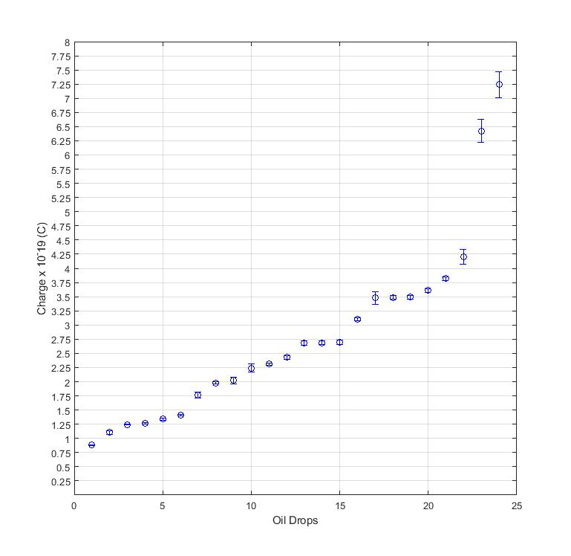

Figure 5: Calculated charge for each oil drop measured with uncertainty bars sorted from least charge to greatest charge. Based on this data, the fine spacing of data points, and the fact that few uncertainties overlap, we are unable to conclude that charge is quantized.

Figure 1 displays the results of our experiment. Due to the fact that our uncertainties are relatively small compared to the separation of data points charge-wise (i.e., few data point’s uncertainty bars overlap on the same charge values), we are unable to conclude that charge is quantized. If charge were quantized, many different drops would all be measured to be on the same “level” of charge. If we change the scale of the charge quantization in Figure 1, several groupings of data points appear more obvious, such as the grouping of three data points with charges of . However, there are still many data points (namely data points with lower charges) that appear to fall between “levels” of charge. If our data supported the hypothesis that charge is quantized, we would see a “staircase” rising as we go to the right, with many charges forming groups at similar levels of charge, and the difference in charge between values being large relative to the value of the charges. Unfortunately, we see more of a “slide”. At our scale of measurement, most charges do not fall into a unified group with other charges by them.

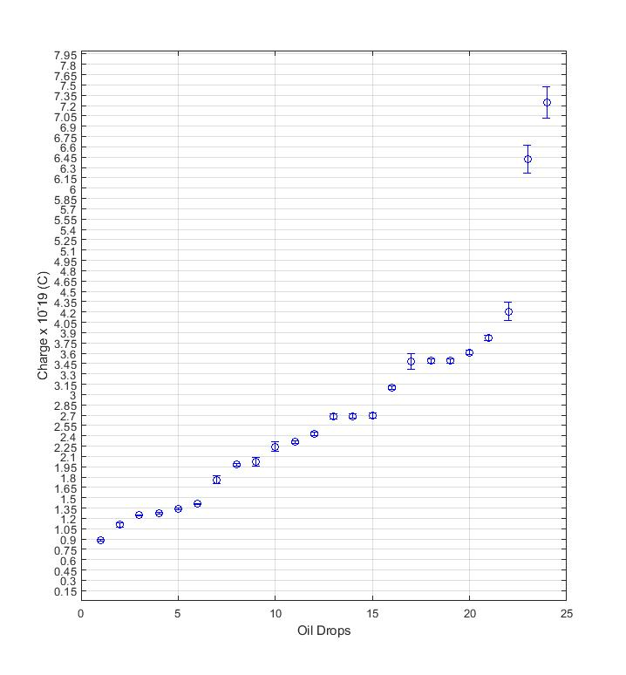

Figure 6: A finer spacing in our charge axis reveals some grouping of charges, but still not enough to support a conclusion that charge is quantized.

Of course, if we make the quantization of charge less and less, yes our data *could* support charge quantization, but at the scale at which we took our data, we do not have conclusive evidence that charge is quantized. Very few data points’ uncertainty bars overlap on the same values, leading us to conclude that we can not determine at this scale if charge is quantized or not.

I believe the reason for this result of a “slide” rather than a “staircase” is twofold. First of all, it appears that our data was not taken precisely enough. There were many, many opportunities to introduce systematic errors into our data during this experiment from not correctly calibrating the scale when running the MATLAB script to calculate velocities, to determining exactly what frame the switch controlling the potential across the plates was flipped. Secondly, our uncertainties for our data are surprisingly small. I believe that there may have been systematic errors or calculational errors while we were determining our uncertainties, because I would expect them to be larger.